Project Design Phase-II
Data Flow Diagram & User Stories

Date | 25 February 2026
Team ID | LTVIP2026TMIDS78743
Project Name | Cafeteria Menu Display Main
Maximum Marks | 4 Marks

Data Flow Diagrams:
A Data Flow Diagram (DFD) is a traditional visual representation of the information flows within a system. A neat and clear DFD can depict the right amount of the system requirement graphically. It shows how data enters and leaves the system, what changes the information, and where data is stored.
Data Flow Diagram (DFD) - Educational Organisation System :
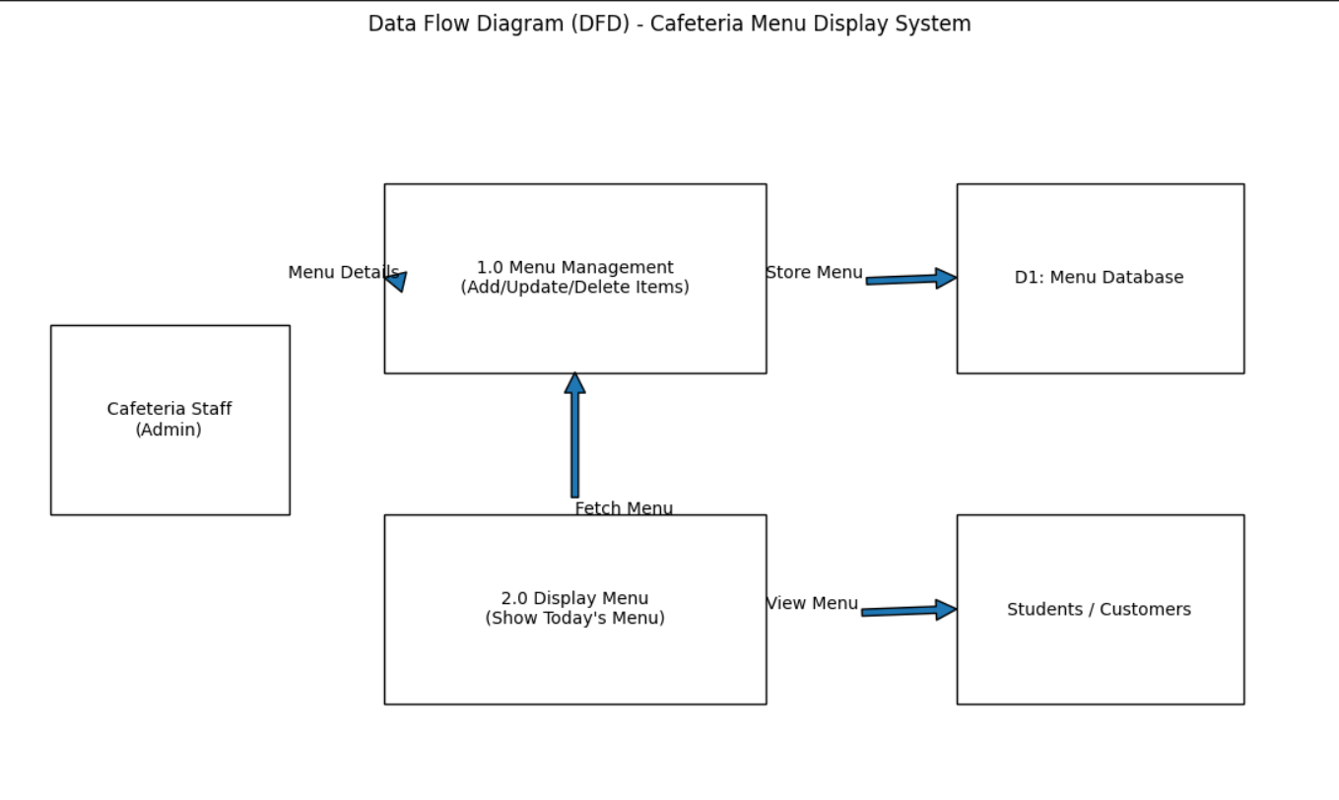
User Stories
User Type | Functional Requirement (Epic) | User Story Number | User Story / Task | Acceptance criteria | Priority | Release
Developer | Project Setup | USN-1 | Set up development environment with Flask and MySQL. | Flask server runs locally and MySQL database is connected successfully. | High | Sprint-1
Developer | Project Setup | USN-2 | Create project folder structure and initialize Git repository. | All folders (backend, frontend, database) are created and code is version controlled. | High | Sprint-1
Developer | Database Design | USN-3 | Create Users table for admin authentication. | Table stores username and hashed password with unique ID. | Medium | Sprint-1
Developer | Database Design | USN-4 | Create Categories table for menu organization. | Table stores category names (Breakfast, Lunch, etc.) with display order. | High | Sprint-1
Developer | Database Design | USN-5 | Create Menu Items table for food details. | Table stores name, price, description, category_id, image_url, and availability status. | High | Sprint-1
Developer | Backend Development | USN-6 | Create Flask app with basic routes and configuration. | App runs on http://localhost:5000 | High | Sprint-2
Administrator | Authentication | USN-7 | Implement admin login with session management. | Admin can login with credentials and session persists until logout. | Medium | Sprint-2
Developer | API Development | USN-8 | Build API endpoint to fetch all menu items. | GET /api/menu returns JSON array of all available menu items. | High | Sprint-2
Administrator | API Development | USN-9 | Build API endpoint to add new menu items. | POST /api/admin/add saves new item to database with validation. | High | Sprint-2
Administrator | API Development | USN-10 | Build API endpoints to edit and delete menu items. | PUT and DELETE requests update or remove items from database. | Medium | Sprint-2
Administrator | Admin UI | USN-11 | Design admin panel HTML forms for menu management. | Forms include fields for name, price, category, description, and image upload. | Medium | Sprint-2
Developer | Frontend Display | USN-12 | Design customer display interface with HTML/CSS. | Display shows categorized items with prices in large, readable fonts. | High | Sprint-3
Developer | Frontend Logic | USN-13 | Implement JavaScript to fetch and render menu from API. | Menu items load automatically when display page opens. | High | Sprint-3
Customer | Frontend Logic | USN-14 | Add category-based filtering functionality. | Clicking category tabs shows only items from that category. | Medium | Sprint-3
Customer | Automation | USN-15 | Implement auto-refresh every 5 minutes. | Display updates automatically without manual page refresh.. | Medium | Sprint-3
Customer | UI Enhancement | USN-16 | Add dietary icons (Veg, Vegan, Gluten-Free). | Icons appear next to items based on dietary_tags in database. | Low | Sprint-3
Customer | UI Enhancement | USN-17 | Implement "Today's Special" highlight feature. | Special items show with highlight color and star icon. | Low | Sprint-3
Customer | UI Enhancement | USN-18 | Add "Out of Stock" grayed-out display logic. | Unavailable items appear grayed with "Sold Out" label. | Medium | Sprint-3

